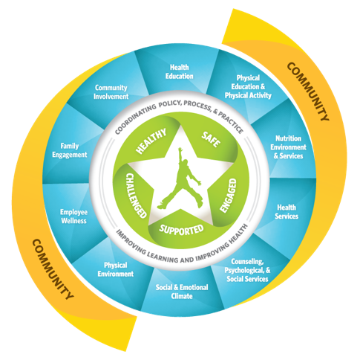

WSCC Team Training Modules
Small Group Reporting Form

Module Name:

Group Review Team Members:

Briefly describe the module.

Highlight the participant learning activities (Script and Handouts) - What will the participants do?

Describe for whom the module would be most beneficial and why.

Other information your group would like to share about the module.

Describe the group’s ideas for using the modules as professional development in your state, districts or schools.

Describe ideas for sharing or advertising the training modules to schools or districts.

